**Bays Theorem**

Bayes provides their thoughts in decision theory which is extensively used in important mathematics concepts as Probability. Bayes theorem is also widely used in Machine Learning where we need to predict classes precisely and accurately. An important concept of Bayes theorem named Bayesian method is used to calculate conditional probability in Machine Learning application that includes classification tasks. Further, a simplified version of Bayes theorem (Naïve Bayes classification) is also used to reduce computation time and average cost of the projects.

Bayes theorem is also known with some other name such as Bayes rule or Bayes Law. Bayes theorem helps to determine the probability of an event with random knowledge. It is used to calculate the probability of occurring one event while other one already occurred. It is a best method to relate the condition probability and marginal probability.

In simple words, we can say that Bayes theorem helps to contribute more accurate results.

What is Bayes Theorem?

Bayes theorem is one of the most popular machine learning concepts that helps to calculate the probability of occurring one event with uncertain knowledge while other one has already occurred.

Bayes' theorem can be derived using product rule and conditional probability of event X with known event Y:



Here, both events X and Y are independent events which means probability of outcome of both events does not depends one another.

The above equation is called as Bayes Rule or Bayes Theorem.

* P(X|Y) is called as posterior, which we need to calculate. It is defined as updated probability after considering the evidence.
* P(Y|X) is called the likelihood. It is the probability of evidence when hypothesis is true.
* P(X) is called the prior probability, probability of hypothesis before considering the evidence
* P(Y) is called marginal probability. It is defined as the probability of evidence under any consideration.

In other words,

**Bays Theorem is written as:**



============================xxxxxxx

Naïve Bays Classifier:

Working of Naïve Bayes' Classifier:

Working of Naïve Bayes' Classifier can be understood with the help of the below example:

Suppose we have a dataset of weather conditions and corresponding target variable "Play". So using this dataset we need to decide that whether we should play or not on a particular day according to the weather conditions. So to solve this problem, we need to follow the below steps:

Convert the given dataset into frequency tables.

Generate Likelihood table by finding the probabilities of given features.

Now, use Bayes theorem to calculate the posterior probability.

Problem: If the weather is sunny, then the Player should play or not?

Solution: To solve this, first consider the below dataset:



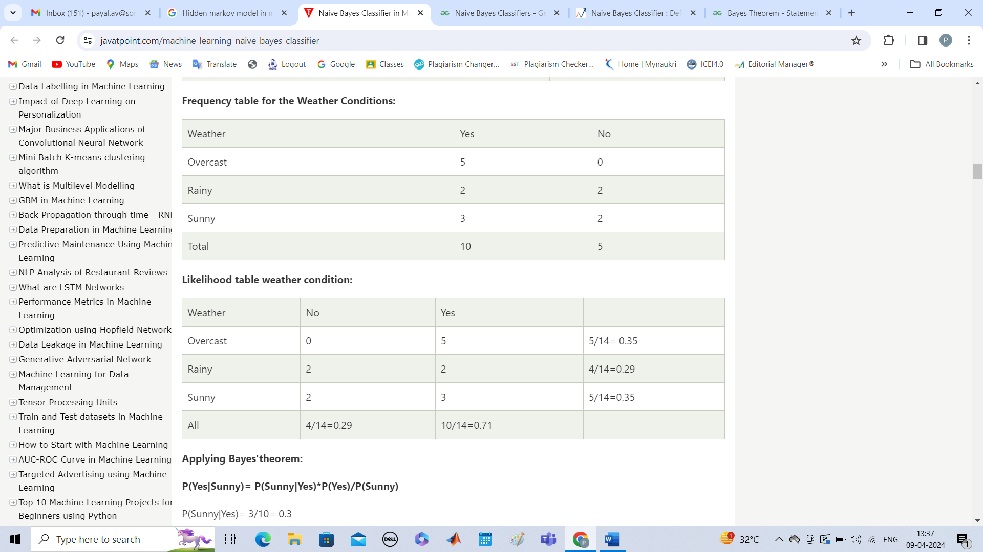

**Applying Bayes'theorem:**

**P(Yes|Sunny)= P(Sunny|Yes)*P(Yes)/P(Sunny)**

P(Sunny|Yes)= 3/10= 0.3

P(Sunny)= 0.35

P(Yes)=0.71

So P(Yes|Sunny) = 0.3*0.71/0.35= **0.60**

**P(No|Sunny)= P(Sunny|No)*P(No)/P(Sunny)**

P(Sunny|NO)= 2/4=0.5

P(No)= 0.29

P(Sunny)= 0.35

So P(No|Sunny)= 0.5*0.29/0.35 = **0.41**

So as we can see from the above calculation that **P(Yes|Sunny)>P(No|Sunny)**

**Hence on a Sunny day, Player can play the game.**

Advantages of Naïve Bayes Classifier:

* Naïve Bayes is one of the fast and easy ML algorithms to predict a class of datasets.
* It can be used for Binary as well as Multi-class Classifications.
* It performs well in Multi-class predictions as compared to the other Algorithms.
* It is the most popular choice for text classification problems.

Disadvantages of Naïve Bayes Classifier:

* Naive Bayes assumes that all features are independent or unrelated, so it cannot learn the relationship between features.

Applications of Naïve Bayes Classifier:

* It is used for Credit Scoring.
* It is used in medical data classification.
* It can be used in real-time predictions because Naïve Bayes Classifier is an eager learner.
* It is used in Text classification such as Spam filtering and Sentiment analysis.

=======================xxxxxxx==================

Hidden Markov Model